‘Lord, Teach us to Pray’

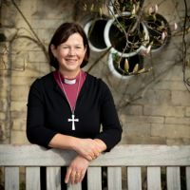
The disciples asked this simple question of Jesus as they watched him spend time with his father in quiet and solitude. They must have noticed the way in which Jesus so easily drew close to God and made time to do so. They longed for this type of relationship themselves and so asked that Jesus would show them how to pray in order to experience this for themselves.
In our Year of Prayer, we are discovering ways in which we can draw closer to God and deepen our own prayer lives and it is exciting to hear of the different ways in which many of you are exploring this further.
Thy Kingdom Come is a national and international campaign that encourages us to pray for others, that they may come to know Jesus, and takes place between Ascension Day and Pentecost. The focus this year is on the Lord’s Prayer and so can help us with our own events. I do hope you will explore the resources that are available and see what you can do in your parishes during this time. How wonderful it would be to see the results of those prayers as more people come to find out more about Jesus and know his love for them.
Let’s keep praying!


Diocese of Peterborough - Magazine Resource - May 2025
Produced by the Diocesan Office, The Palace, Peterborough, PE1 1YB
Tel: 01733 887000 Email: communications@peterborough-diocese.org.uk
www.peterborough-diocese.org.uk

