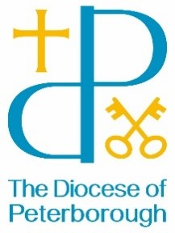
BISHOP’S LETTER 29
13 May 25

Dear Friends,

Fifty years ago this month, West Ham United won the FA Cup at the Empire Stadium in Wembley, beating Fulham 2-0. Interestingly, 21 out of the 22 players were from England, with the remaining player coming from the Republic of Ireland. Each team was allowed one substitute and both of these were also from England. Since then, the world has become a smaller place where it is no longer strange to meet people from different cultures and backgrounds. In last year’s FA Cup final, at the new Wembley Stadium, there were 14 different nationalities amongst the 22 players who took to the pitch. The Bible reminds us that God is our unity. Wherever we come from, “We are all one in Christ Jesus.”

When John was writing the Book of Revelation, he said: “There was a great multitude that no one could count, from every nation, from all tribes and peoples and languages, standing before the throne.” The world standing shoulder to shoulder, united in praise for God and at ease with one another. It’s good to remember in a time of tariffs, walls, threats, incursions and divisions, that Jesus spoke of a Samaritan who showed courage and selfless kindness to a Jew. The social norms dictated that they should not have even been talking. Jesus broke social rules that were designed to push people away rather than build them up. Let’s have some of the courage that Jesus showed.

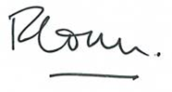

The Venerable Richard Ormston
Archdeacon of Northampton

