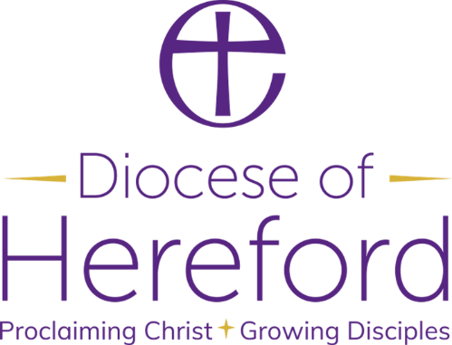

ARCHDEACON’S VISITATIONS 2025

PLEASE RETURN THIS SLIP IMMEDIATELY AFTER THE ANNUAL PAROCHIAL CHURCH MEETING BUT IN ANY EVENT NOT LATER THAN 2nd JUNE 2025

Deanery: _______________________________________________________

Parish: _________________________________________________________

Date of Visitation: ________________________________________________

Venue: _________________________________________________________

Time: ______________________________

Names of Churchwardens attending:

_____________________________________________________

_____________________________________________________

Please return this completed slip to:
Sarah Hedley, The Diocesan Office, The Palace, Hereford HR4 9BL or
annualreturns@hereford.anglican.org

