
A Brief History of LLM / Reader Ministry


The role of the lay person who is trusted to read the Scriptures publicly and teach others has a long history which is rooted in the Jewish synagogues. Over the centuries, these people have been known as ‘lector’, ‘Reader’ and ‘Licensed Lay Minister’ (and were probably the ‘rabbis’ of Jesus’ time). In the following history, no difference is implied in the names except the time period when they have tended to be used.

In Jesus’ time, the Temple in Jerusalem was the focus for the Jewish priests while lay people ran the synagogues. Some managed the administration, but educated Jewish men could read from Scripture and explain it to the congregation. Jesus fulfilled this role in the synagogue at Nazareth. Although the early Christian church had few formal roles, we know that some people took leadership roles involving oversight or pastoral responsibilities. Others were called to read, preach and teach. These ‘lectors’ or ‘Readers’ were ‘official lay ministers of the church’ and are referenced in early documents. They continue in many traditions including Orthodox and Roman Catholic therefore the ‘existence of an order of Readers… is a constant’ and ‘Readers are not simply an Anglican institution’ but ‘are admitted to an ancient order common to the Church Universal’.
However, during the reign of Emperor Constantine (d.337 AD), Christianity became the preferred state religion and ‘Reader’ became one step towards ordination, although it has always been a lay role.
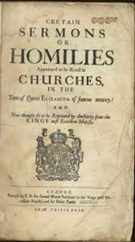
During the religiously and politically turbulent reigns of Henry VIII, Edward VI, Mary and Elizabeth I, the number of clergy fell drastically. The Archbishop of Canterbury, Matthew Parker, therefore allowed incumbents to appoint ‘some sober honest and grave layman who as lector or Reader shall give his attendance to read the order of service appointed’ with five being ‘ordained lector’ in January 1560. The role of these Readers varied; some did little more than read services and homilies, while others were active in missionary and pastoral work within the parish. This mixture of missional activity and working within the church is frequently evident in the role of the Reader and is still a key distinctive of Reader/ LLM ministry.

As the nation became more settled, and Anglicanism became more established, more clergy were trained and the need for lay Readers in England again disappeared. However, some laypeople continued to act as Readers in more missional settings. The Society for the Propagation of the Gospel in Foreign Parts (SPG), founded in 1701, employed lay Readers who could also be catechists, school masters or school mistresses. They were often appointed to lead new churches in communities and villages. The missional and church parts of the role were clearly seen.
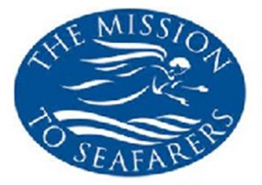
Between 1800 and 1900, the population of England grew rapidly. For example, the population of Bristol increased from 60 000 to 330 000, while Swindon’s population grew from 1198 to 45 000. New housing estates had few clergy and many working-class people considered clergy as part of the ‘oppressor’ class, so significant areas of the country were unreached by the Church. In 1850, the Bishops faced these issues and resolved to reinstate the Order of Readers. Therefore in 1866, the authorised office of lay Reader was reintroduced to the mainstream church – very slowly. Some clergy ‘were anxious about the concept of lay leadership in worship and in preaching and there was also an expressed uncertainty about the role and place of Reader ministry in the structures and organization of the church’ while congregations were equally unused to lay ministry. However, Readers were empowered to ‘render general aid to the clergy in all ministrations not strictly requiring the service of one in Holy Orders; to read lessons in Church; to read prayers and Holy Scripture, and to explain the same…’. Readers were also encouraged to help ‘clergymen and others in… mission work’ holding services in prisons and workhouses, for sailors and other marginalised groups. This office was unpaid, licensed by the Bishop and with the incumbent’s agreement.
During the World Wars, many clergy became army chaplains. Readers also enlisted and frequently led services, but qualified lay people were still needed to lead services and care for congregations at home. Readers responded to the needs that they saw and were used extensively during the war years.
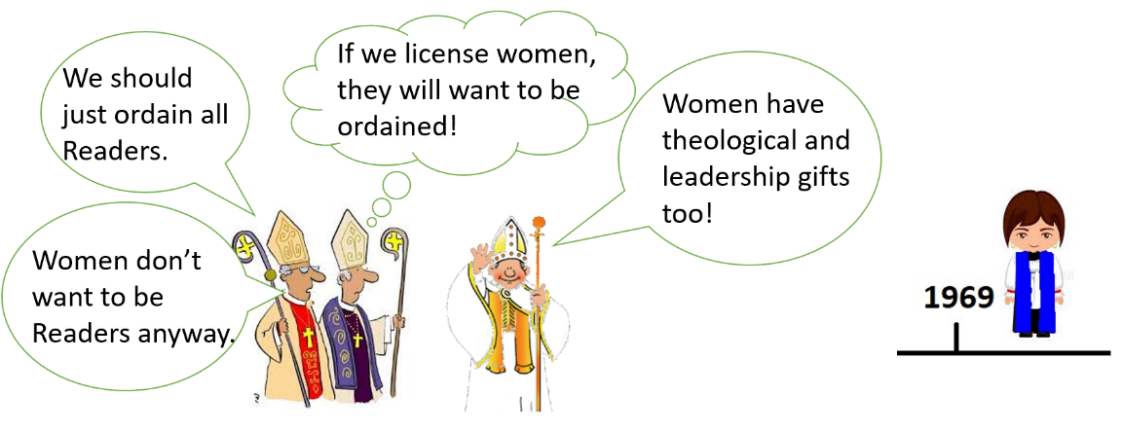
Between 1910 and 1935, there was a call to ordain women, matching the increasing freedom of women in the workplace. Stipendiary lay women had been trained and worked from 1887 in the Church Army and, slowly, women were being allowed to assist with services. In 1935, an Archbishops’ Commission considered the ministry of women. Although it recommended that women should be able to exercise ministry as deaconesses, lay workers and Church Army Sisters, they believed that the ‘general mind of the Church’ recognised the ‘continuous tradition of a male priesthood’. Nevertheless, they suggested that women should be licensed as lay Readers and, in 1969, the first women were licensed as Readers. The extent of any Reader’s ministry (male or female) still depended on the attitude of their Bishop and incumbent, so potential Readers could be ignored. Nevertheless, since 44 women were licensed as Readers before December 1970, it appears that many clergy and Bishops were supportive.
These new Readers had various experiences of training, from the academic ‘Archbishops’ Diploma for Readers’ to an informal apprenticeship to none. The Church therefore considered Reader training with a report published in 1989 and superseded in 2000 by Reader Ministry and Training 2000 and beyond. This latter report described Readers as having a ‘bridge ministry’ and being ‘leaders in their community’ as well as lay preachers, leaders of worship, pastors and teachers, organisers and ‘spiritual people’. It recognised changes in wider society and offered suggestions for Reader training, including implications for workplace, multicultural society and collaborative ministry.
Thus, in the 1900s, the same common themes emerged. The Church recognised the need for lay involvement in both Church and mission as society became more secular and multicultural. Readers were key to this strategy.
The report Reader Upbeat in 2008 analysed Reader ministry and offered recommendations, including increased collaboration between ordained and licensed lay ministries, and increased opportunities for Readers inside and outside buildings. It also recognised Reader ministry as ‘the best trained and resourced lay ministry with a wide variety of opportunities’ and recommended that the name of Reader be changed to ‘Licensed Lay Minister (Reader)’ or ‘LLM’ .
The report Setting God’s People Free in 2017 noted that the Church spent little on training lay people. Often they received good training in the workplace but it is ‘a very rare person who is equipped to critique [secular] training from a biblical perspective’. The report adds that this Biblical perspective of the secular ‘frontline’ world cannot easily be done by clergy because ‘the formation and training of clergy de-emphasises such a perspective, and clergy inevitably develop distance from their prior workplace experience’. Hence ‘theologically educated lay people’ are vital in our churches in order to encourage discipleship in congregations and the same ‘theologically educated lay people’ are also vital to the extension of God’s Kingdom in the wider world. LLMs creates bridges between the Christian world and the wider secular context that we now live.
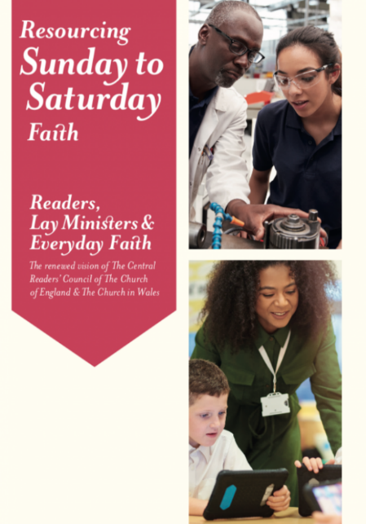
In 2018, new aims / distinctives for LLM ministry were developed which recognised these needs and roles. LLMs still bridge between church and the world, encouraging mission and teaching the faith. Hence LLMs are:
- Teachers of the faith
- Enablers of Mission
- Leaders in Church and Society
In 2021, new ‘qualities’ for LLM selection and training were developed based on these aims. These uphold the value of the minister who is part of the laity and theologically educated and licensed to preach and teach.

Bibliography
Items which are particularly recommended for further reading have an asterisk*.
*Central Readers' Council, 2019. Resourcing Sunday to Saturday Faith. [Online]
Available at: https://transformingministry.co.uk/publications-handbooks/#resourcing-sunday-to-saturday-faith [Accessed 1 July 2020].
Church Times, 2019. Sex is Irrelevant to this Office. [Online]
Available at: https://www.churchtimes.co.uk/articles/2019/3-may/features/features/sex-is-irrelevant-to-this-office
[Accessed 14 Sept 2020].
Coleman, J. A., 1985. A Theology of Ministry. The Way, Jan, pp. 7-18
Garner, P., 2010. The Reader: an exploration of the history and present place of Reader ministry in the Church of England, s.l.: University of Leeds.
*Hiscox, R., 1991. Celebrating Reader Ministry. London: Mowbray.
King, T., 1973. Readers: A Pioneer Ministry. London: The Miss Myland Fund
Ministry Division of the Archbishops' Council, 2008. Reader Upbeat: Quickening the Tempo of Reader Ministry in the Church Today, London: Church House Publishing
*Rowling, C. & Gooder, P., 2009. Reader Ministry Explored. London: SPCK
The Archbishops' Council, 2000. Reader Ministry and Training 2000 and beyond, London: Ludo Press Ltd.
The Archbishops' Council, 2004. Women Bishops in the Church of England. London: Church House Publishing.
*The Archbishops' Council, 2017. Setting God's People Free GS2056. [Online]
Available at https://www.churchofengland.org/sites/default/files/2017-11/gs-2056-setting-gods-people-free.pdf
[Accessed 16 June 2023].
*Tovey, P., Buck, S. & Dodds, G., 2016. Instruments of Christ's Love. London: SCM Press.
Young, F., 2020. Readers in the Eastern Churches. Transforming Ministry, Winter, 120(4), pp. 17-18

SJHayton June 2023

E.g. Zechariah in Luke 1:8
E.g. Luke 13:14 and Jairus in Mark 5:21-23.
Luke 4:17
Hebrews 13:17, 1 Tim 3:1
Acts 6:1-6
(King, 1973, pp. 48-49) and see 1 Timothy 4:13, Colossians 4:16, Revelation 1:3
Justin Martyr (d.165) discussed those who read the Scripture and those who instruct. The unknown author of 2 Clement, written 130-160 AD, mentioned ‘him who reads an address in your midst’ whilst a letter to the Bishop of Antioch in 251 refers to ‘fifty-two exorcists and lectors’ in Rome.
Many Orthodox traditions appoint Readers who are usually distinct from clergy and ‘proclaim the Word of God’, although only those with appropriate training may preach (Young, 2020) while Pope Paul VI re-opened the order of Reader (or ‘lector’) to ‘approved lay men’ as well as seminarians in 1973.
(Young, 2020)
(King, 1973, p. 68)
(Garner, 2010, p. 52) Matthew Parker was consecrated as Archbishop of Canterbury on 17th December 1559 and reinstating Readers in the Church of England was one of his first acts. Note that ‘ordination’ means a ministerial role given during a religious service so ‘lector’ was still a lay role.
(Garner, 2010, p. 27)
(Tovey, et al., 2016, pp. 78-79)
(Tovey, et al., 2016, pp. 88-90)
(King, 1973, p. 77)
Cathy Rowling and Paula Gooder consider 1866 to be the start of Reader ministry because the earliest references vary in description and the succession is broken (Rowling & Gooder, 2009, pp. 18-19). However, the Church describes 1866 as a ‘revival’ of Reader ministry (The Archbishops' Council, 2000, p. 17) while there is a common thread of lay people who are commissioned to preach and teach reaching back through the centuries. Although the exact role of Readers has evolved, the specific descriptions of clergy ministry have also ‘undergone many mutations’ (Coleman, 1985, p. 10).
(Garner, 2010, p. 29)
(King, 1973, p. 104)
(King, 1973, p. 82)
(Ministry Division of the Archbishops' Council, 2008, p. 31)
(Garner, 2010, pp. 29, 79)
(King, 1973, p. 131)
Deaconesses were seen to be part of ‘a Holy Order’ but not ‘in Holy Orders’ thus different from deacons (The Archbishops' Council, 2004, p. 4.2.25)
(The Archbishops' Council, 2004, p. 4.2.24)
(Garner, 2010, p. 92)
(Church Times, 2019)
(Church Times, 2019)
It is also felt that the introduction of female Readers who could preach and assist at Holy Communion, probably contributed significantly to the ordination of women 25 years later. Congregations and clergy realised that women were capable of holding such offices well!
(The Archbishops' Council, 2000, p. 1)
(The Archbishops' Council, 2000)
(The Archbishops' Council, 2000, p. 4)
(The Archbishops' Council, 2000, pp. 6-7)
(The Archbishops' Council, 2000, pp. 17-24)
(Ministry Division of the Archbishops' Council, 2008)
(Ministry Division of the Archbishops' Council, 2008, pp. 87-88)
(The Archbishops' Council, 2017)
(The Archbishops' Council, 2017, p. 12)
(The Archbishops' Council, 2017, p. 16)
(Central Readers' Council, 2019)

