
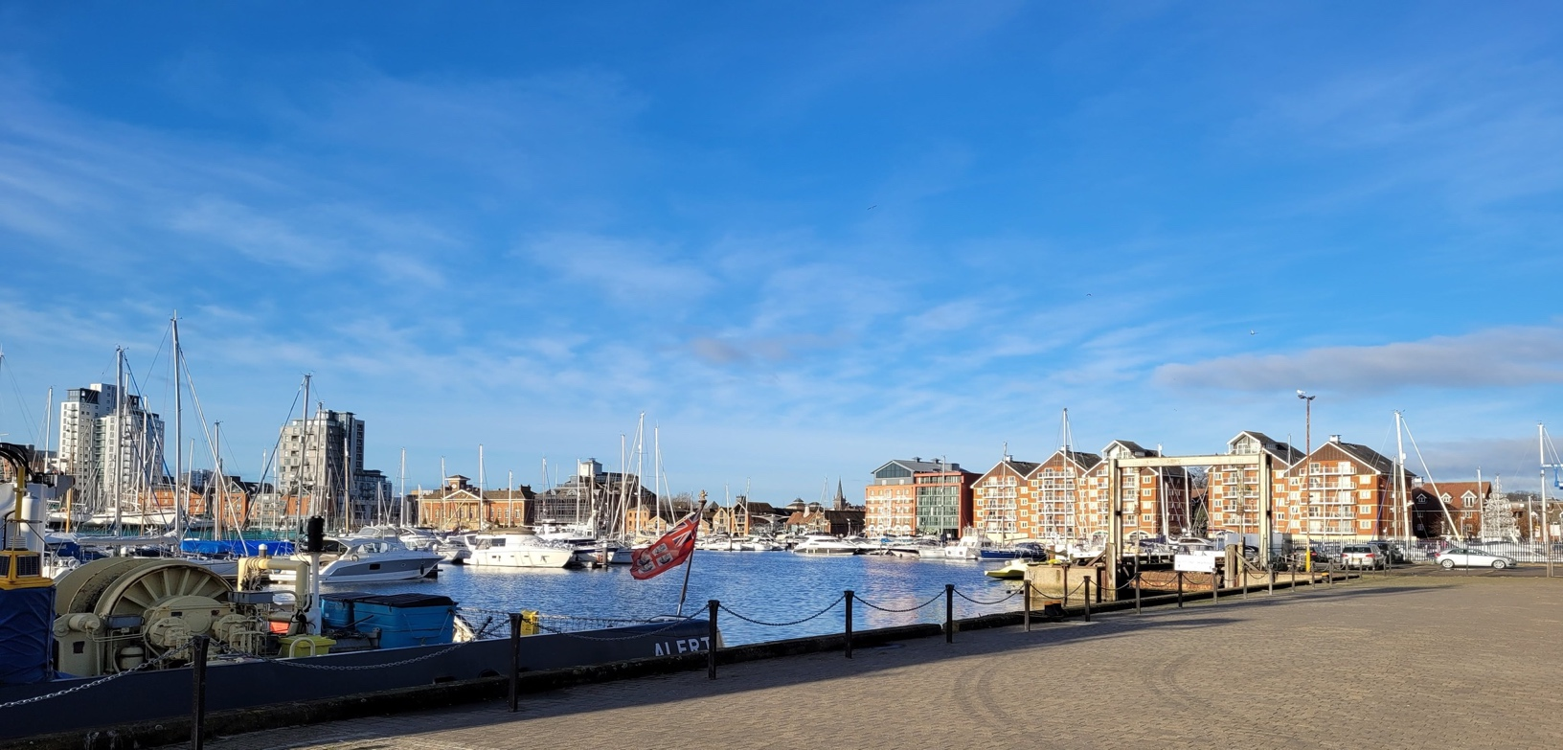

Archdeacon of Ipswich

and Director of Inspiring Ipswich

From the Bishop
We are looking for an outstanding collaborative, prayerful and pastoral leader to help build on the transformative work of the last five years. The new Archdeacon will lead the Archdeaconry through the transition from the “Inspiring Ipswich” project, funded by the SDF, to a sustainable outward-looking, mission-orientated future serving the people of Ipswich.
The Archdeaconry of Ipswich currently serves the population of the county town of Ipswich and four villages to the north and east of the town, a total of about 180,000. This is about a quarter of the population of the Diocese of St Edmundsbury and Ipswich, which itself comprises most of Suffolk except for Lowestoft. Part of the transition beyond the Inspiring Ipswich project will involve determining how the Archdeaconry could be expanded, in consultation with neighbouring deaneries.
Ipswich is a town of many strengths with a population particularly in central Ipswich, that has become increasingly diverse. The creation of the University of Suffolk located on the attractive Ipswich waterfront and the recently promoted premier league Ipswich Town Football Club have all contributed to a growing sense of identity and pride in the town.
The Archdeacon will work closely with a vibrant and passionate deanery team, and be a vital member of the Bishop’s Staff which will be led by Bishop Graeme Knowles as Acting Diocesan Bishop when I retire at the end of February 2025.
The Archdeacon will be a leader, encourager and pastor for the clergy, lay ministers and congregations, continuing to strengthen the spiritual confidence that has grown these past few years, and to build up relationships between congregations and clergy, including across our differences. The Archdeacon will be committed to working ecumenically, and with people of other faiths. The Archdeacon will also be a leader in the community, working particularly on behalf of those in greatest need.
We have a great deal to be thankful for in the Archdeaconry, and we know God is calling us into deeper faith, deeper love, and deeper service. I pray that God will send us someone who will help us grow and together to show and share Christ’s love for the people of Ipswich.

We would like our next Archdeacon to be:
- Supportive and someone who will inspire clergy and laity across all traditions
- Creatively agile and prayerfully open to God-given opportunities
- An experienced strategic leader and enabler of others
- Pastoral, relational, inspirational and missional
- A leader and manager of change
- A skilled and enthusiastic communicator


Growing in God – Inspiring Ipswich
Along with the wider Church of England, the diocese is focused on engaging people anew with the Christian faith, forming flourishing congregations and making a difference for good in our communities.
To help us with this, since 2014 we have had a ‘Growing in God’ vision to grow in depth, to grow numerically, to grow younger and to grow in influence for good across Suffolk.
In Ipswich, we have been working since 2019 on revitalising the deanery with an SDF Funded project called Inspiring Ipswich. The total number of people in our worshipping communities has grown by 35% (despite Covid), and the average weekly attendance of children and young people by 32%. We have made contact with over 22,000 new people and seen 1,200 of those come to worship with us at least monthly; many of them coming to get baptised or confirmed. We now have over 40 new worshipping communities including 10 regular ‘Messy Churches’. We have 10 Top-up shops providing food and other basics for people in need. Over 50 people have completed the CPAS ’Growing Leaders’ course; over 200 have been through the ‘Leading Your Church into Growth’ (LyCiG) process. Nine clergy have been trained through our Auxiliary Ordained Pathway (AOP).
We have networks, support groups and parties for our clergy, lay leaders, churchwardens and treasurers. Our bi-annual conferences are well attended.
On top of this we have established good engagement with our schools together with setting up chaplaincies at places of further and higher education. We have growing estate ministry in Ipswich.
The civic church of Ipswich (St Mary le Tower) will become Ipswich Minster in January 2025.
We are now looking to build on this
We have one year left of our original Inspiring Ipswich project so this role will involve being the Director of Inspiring Ipswich for at least the first year. After that, we are keen to build on what God has already been doing here and to go even deeper and further. We also want to embed the learning and inspire the rest of the diocese.

About the Diocese

The Diocese of St Edmundsbury & Ipswich's four mission priorities are to grow in 'depth' and 'influence', so as to enable an increase in 'number' and become 'younger': in achieving the vision of “Growing in God” by being “Flourishing Congregations, Making a Difference”.
The boundaries of the Diocese of St Edmundsbury and Ipswich are co-terminus with the county of Suffolk (with the exception of Lowestoft and its surrounding areas and one parish in the county of Essex). The Diocese is roughly 35 miles north to south and 50 miles east to west, having a total area of 1,439 square miles. Ipswich is the county town, and its population makes up nearly one-quarter of that of the Diocese.
We have three archdeaconries: Sudbury (West Suffolk), Suffolk (East Suffolk) and Ipswich, each served by an Archdeacon, with a fourth Archdeacon for Rural Mission. There are 16 deaneries, 125 benefices, 442 parishes, with 478 church buildings, 419 of which are listed Grade I or II*.
The cathedral, the mother church of the diocese and the seat of the bishop's mission and ministry, is located in Bury St Edmunds. The cathedral plays an important and active role in supporting and resourcing parishes across the diocese.
The Archdeaconry of Ipswich currently consists of 24 parishes (organised in 21 benefices) and three church plants under Bishop’s Mission Orders (BMOs) with a variety of ministry provision including full-time stipendiary, self-supporting ordained ministers (SSMs), Readers, and Elders (commissioned lay ministers), all collaborating with a large number of voluntary officers and ministry leaders in the churches.
The Archdeacon of Ipswich has fulfilled the dual role of being Director of Inspiring Ipswich since 2019. That project is due to complete at the end pf 2025 after which the Archdeacon will continue to work on embedding and extending the learning and experiences of the project into the deanery and the wider diocese.
The boundaries of the Archdeaconry are currently under review. Consultation will commence soon on a reconfiguring of the boundaries of the three archdeaconries. The Archdeaconry of Ipswich will, in time, cover a larger geographic area.

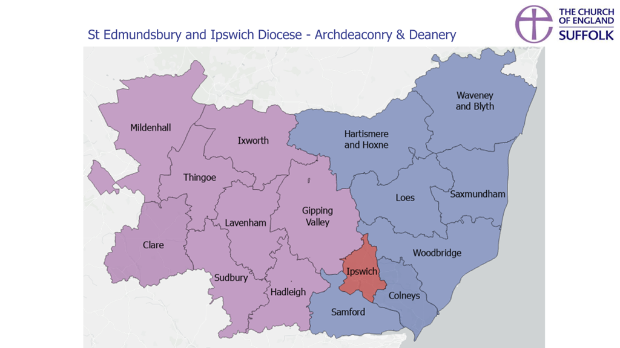

Responsibilities
The Diocese is seeking to appoint a strategic leader and enabler of mission and ministry for the Archdeaconry of Ipswich. The new archdeacon will support and encourage clergy and laity to respond ambitiously to God’s call to the Church in every community. The successful candidate will have strong leadership experience in parish life, ideally in both urban and rural contexts and, in leading and managing change.
In 2025 when SDF funding for Inspiring Ipswich ends, the Archdeaconry of Ipswich will expand as already described to include benefices from the other two archdeaconries. The Archdeacon will retain responsibility for work arising from the Inspiring Ipswich project.

Leadership

The Archdeacon will:
- Be a disciple of Jesus Christ with a heart for the kingdom of God.
- Preach and lead worship in a way that inspires and deepens faith in God.
- Be rooting their life in the discipline of prayer.
- Be a strategic leader for the Archdeaconry.
- Undertake with enthusiasm and efficiency the statutory duties of an archdeacon, including those laid out in Canon C22 and other ecclesiastical legislation.
- Promote and enable collaboration in ministry and mission, including the sharing of resources across the archdeaconry and wider diocese.
- Provide strategic direction and an appropriate combination of challenge and support to clergy, to encourage and enable them to achieve the shared aspirations for Growing in God.
- Support the development of a mixed ecology of congregations and worshipping communities, including established congregations and new congregations generated through the SDF projects.
- Equip and support Incumbents, Local Ministers, Church Planters, Pioneers, and Lay Leaders for the worshipping communities in the archdeaconry. Be willing to contribute in supporting and developing the gifts of emerging leaders.
- Be an advocate for the church’s role in community engagement; particularly for those who are disadvantaged and harder to reach.
- Be responsible for specific diocesan portfolios of work as agreed with the Bishop.
- Encourage financial generosity, financial sustainability and good practice in fundraising and stewardship.
- Address difficulties or disputes as they arise in parishes; to seek resolutions through advice and negotiation, but where necessary take formal action under the Clergy Disciplinary Measure and other legislation concerning the conduct of Clergy, Churchwardens and PCCs.
- Ensure that safeguarding is embedded in church culture and that policies are properly implemented across the board.
- Work with the Bishops' Staff Team on plans to sustain the missional progress made in the Ipswich Deanery beyond the life-time of the Inspiring Ipswich SDF project to ensure the learning from the project is applied and embedded into the wider diocese.

Ministerial development and well-being
- Ensure excellent support and care is offered to clergy colleagues and ministry teams and churchwardens.
- Conduct annual reviews (MDR) and ensure that Archdeacon’s Visitations are used to support a review of Parish mission action plans, to discuss future plans, and to identify needs for development or support.
- In collaboration with the Bishop and others, provide support to clergy and their families and ensure appropriate professional pastoral care provision where needed, ensuring that issues are dealt with professionally and sensitively, praying for and with them and providing spiritual advice when the occasion arises.
- Address matters of concern regarding wellbeing of leaders (clergy and lay) with the Bishops or others as appropriate, especially in cases of significant illness.
- Support new clergy and other leaders taking up posts in the archdeaconry. Provide signposting to resources and facilities to help clergy and other leaders to develop.

Inspiring Ipswich Project
As Director of the Inspiring Ipswich Project, the Archdeacon of Ipswich will:
- Take the knowledge and experience gained from the first 6 years of the project and seek ways to embed that into the deanery of Ipswich and apply it across the wider diocese.
- Ensure the sustainability and maturity of existing Inspiring Ipswich activities and champion growth in churches, acting as an advocate for the development of new congregations.
- Discern and lead where God is calling the deanery for the next five years.
- Be accountable for the use of the remaining SDF and diocesan funds.
- Set in train the structures and plans for the next phase of growth across Ipswich.
- Line manage the inspiring Ipswich Project Manager.

Over the five years that follow the end of the current funding (and subject to on-going funding) the Archdeacon will need to:
- Focus on helping the churches to continue to grow younger; reaching out more effectively through toddler groups, working more closely with local schools and establishing more community-focussed youth groups.
- Contribute to the next Strategic Mission and Ministry Investment Board (SMIBB) applications.

Collaboration
This role will only be possible with significant collaboration and sharing of resources with many across the Archdeaconry and wider Diocese.
The post holder will communicate regularly and effectively with those in the Ipswich Archdeaconry and the Bishops and other Diocesan staff. This will include attending a weekly meeting with the Bishops and other archdeacons, Bishop's Staff meetings, Bishop’s Council and other meetings.

Key Relationships:
- The Bishop, Diocesan Secretary, Archdeacons, and other members of the Bishop’s Staff Team.
- Area Deans and Deanery Lay Chair and Deanery Leadership Team
- Clergy, Lay Leaders, Lay Ministers
- Director of Mission & Ministry and appropriate members of the Mission & Ministry Team
- Diocesan Officers such as the Diocesan Safeguarding Officer and Director of Engagement
- Diocesan Strategic Programme Board and Programme Manager
- Chair of ‘Together for Ipswich’
The post holder will be a capable public representative of the Church of England in wider society and with ecumenical and other partners.

Appointments and Staffing
When a vacancy arises, the Archdeacon will have a key role in the appointment process. In particular s/he will collaborate with Bishops and relevant parties to ensure that any appointment made will be in accordance with the relevant deanery plan and the diocesan deployment strategy and with the provisions of the Patronage (Benefices) Measure 1986.

During a vacancy:
- Sharing in the recruitment process for new incumbents as agreed with the patron and Bishop (e.g. working with the Bishops on Section 12s).
- Keeping mission as a priority when helping to recruit, induct, and support new clergy and lay ministers.
- Supporting churchwardens and benefice ministry teams during vacancies.

Support in fulfilling the role
PA support will be provided to assist with administration.
Regular meetings with the bishops including a weekly meeting with the bishop, archdeacons, diocesan secretary and Director of Mission and Ministry.
The successful applicant will be offered a mentor and opportunities for training and development depending on individual needs.

Accommodation
It is proposed that the accommodation for the Archdeacon of Ipswich will be a well-appointed parsonage house in Ipswich. Further details are available upon request.

Travel
The Archdeacon must be able to commit to efficient and effective travel across the diocese by car or other suitable means as appropriate. This will include evening working.

Person Specification

Essential Experience:
- Strong leadership experience in parish life as an incumbent, ideally with experience of responsibility as a Rural Dean and/or another senior diocesan role
- A good understanding of ministry in a variety of contexts, especially of ministry in an urban or estate context
- Experience in growing congregations in urban, suburban and rural contexts and gifted to encourage others to do the same
- Experience in leading and managing change within an organisation, including culture change
- Experience in encouraging and developing others (this may take a variety of forms e.g. coaching, mentoring, spiritual direction, being a Training Incumbent etc.)
- Demonstrable experience of delivering projects and tasks through to completion
- A good understanding of financial management and stewardship
- A strong knowledge and experience of safeguarding practices

Personality and Character

Personal qualities should include:
- Abilities to develop strategies and to translate them into a deliverable plan
- A good sense of humour with a warm and open demeanour
- A collaborative approach and a willingness to work with colleagues across the diocese
- An ability to model a responsible and healthy life balance
- Reflective and prayerful with healthy established patterns to nurture their spiritual wellbeing.
- Theological acuity and a commitment to continuous theological engagement and learning
- The capacity to be flexible and to work under pressure, with good levels of personal organisation and an ability to work to deadlines.
- Resilience and the ability to maintain focus and momentum despite challenges, to find creative ways of dealing with difficulties, and to accept and deal with criticism in a constructive way
- Excellent communication skills and an ability to relate across a wide range of church traditions and social and ethnic contexts
- Confidence and ability in handling sensitive information
- The ability to have difficult conversations where there are barriers to culture change or progress, and to approach these sensitively and constructively
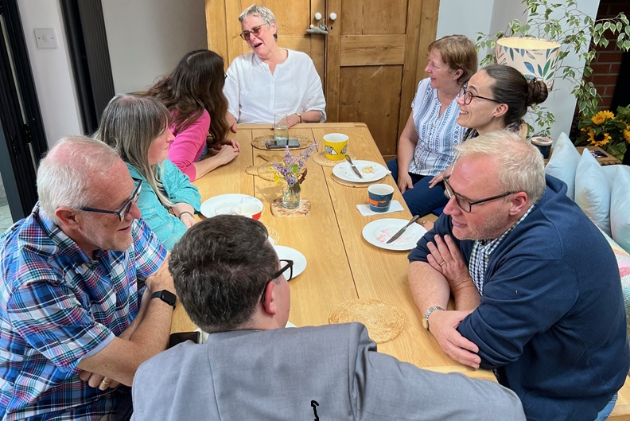

Links to further information:
Diocesan website: https://www.cofesuffolk.org/
Inspiring Ipswich:
Inspiring Ipswich - Diocese of St Edmundsbury and Ipswich
Inspiring Ipswich - What we Learnt - Diocese of St Edmundsbury and Ipswich

Appointment Process
Please use the application form available at: www.cofesuffolk.org/vacancies
The closing date for applications is Wednesday 20th November 2024
Shortlisted candidates will be invited to interview on Monday 9th December 2024
For further information or a conversation about this post, please contact The Bishops' Office on 01473 252829

The Inspiring Ipswich Prayer
(this has been prayed every weekday for almost six years)
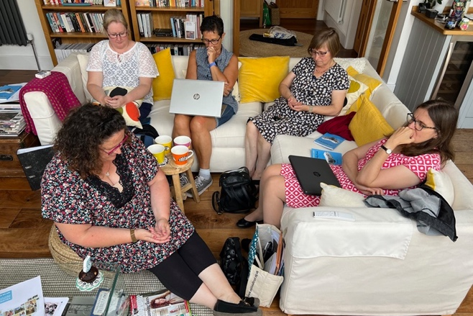
God of Mission, who alone brings growth to your church,
send our Holy Spirit to give joy to our worship,
vision to our planning, wisdom to our actions
and power to our witness.
Help your Church here in Ipswich to grow leaders,
to grow younger, to grow in numbers,
in spiritual commitment to you
and in service to our local community,
through Jesus Christ, our Lord. Amen

C 22 Of archdeacons
1. No person shall be capable of receiving the appointment of archdeacon until he has been six years complete in holy orders and is in priest's orders at the time of the appointment.
2. Every archdeacon within his/her archdeaconry exercises the jurisdiction which he has therein as an ordinary jurisdiction.
3. Such jurisdiction is exercised either by the archdeacon in person or by an official or commissary to whom authority in that behalf shall have been formally committed by the archdeacon concerned.
4. Every archdeacon shall within his/her archdeaconry carry out his duties under the bishop and shall assist the bishop in his pastoral care and office, and particularly he shall see that all such as hold any ecclesiastical office within the same perform their duties with diligence, and shall bring to the bishop's attention what calls for correction or merits praise.
5. Every archdeacon shall within his/her archdeaconry hold yearly visitations save when inhibited by a superior Ordinary; he shall also survey in person or by deputy all churches, chancels, and churchyards and give direction for the amendment of all defects in the walls, fabric, ornaments, and furniture of the same, and in particular shall exercise the powers conferred on him by sections 45 to 47 of the Ecclesiastical Jurisdiction and Care of Churches Measure 2018; he shall also, on receiving the directions of the bishop, induct any priest who has been instituted to a benefice into possession of the temporalities of the same.

