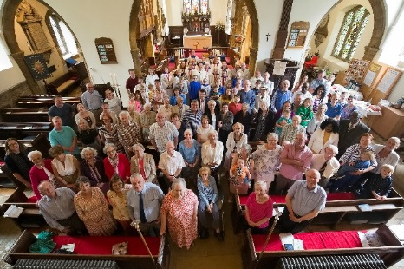
Abington Pastoral Letter No.11 06.05.2020

Dear Friends

Resilience and Rest
There are talks going around about how we might be able to come out of this lockdown. It appears that there will be some elements of social distancing remaining even if the lockdown is lifted. There are reports about how the lockdown is affecting people’s mental health and levels of anxiety and stress.
It would be important that we, as Christians, continue to remain as a calm and non-anxious presence in our community. Let’s continue to encourage each other in sharing God’s love and light with others in our community. More and more people are turning to God and finding comfort in religion. According to one report, nearly 1 in 4 adults in the UK watched or listened to a religious service since the lockdown. In the last 48 hours, more than 6,000 people phoned a prayer hotline: Daily Hope 0800 804 8044 provided by the Church of England. A third of young adults aged between 18 and 34 had watched or listened to an online or broadcast service. In Abington we continue to have on average about 100 people watching live our online worship on Sunday. The view counts on both Facebook and Youtube then during the week become nearly 500. I have been receiving so many thank you messages about how much they appreciate the ministry, the support, the friendship, the phone call, the children’s craft pack, the prayer, the grocery shopping bag, the online worship, the creative bible reading they receive from the church. This is a testimony about how we can ‘be the Church’ while the church building is closed.
Friends, thank you for being the Church to your neighbours, friends and to your family members in these difficult times. Thanks to your faith and love in Christ, I am confident that we will get through this together with a renewed hope and confidence. We are the church. When we live as the Church with Christ in our hearts, we will see lives being transformed.
I am aware though, this comes with a great cost and sacrifice. The cost of lives and also the cost of your well-being. As the social distancing measures continue, our resilience and endurance will be tested more and more. Some of you are feeling often more tired than usual. I also find operating in these extra ordinary circumstances much more intensive and draining. It is hard to draw a boundary between work and home time. You can easily overwork as you continue to remain switched-on.
While we strive to provide calm presence as Christians in our community, we also need to find ways to sustain ourselves. The lockdown inevitably lowers the quality of rest and refreshment. Please be kind yourself and pay attention to your needs. Make sure you get enough rest physically and spiritually. I have been reading psalms out loud every day since the lockdown began and find it comforting. There will be days though that you may feel somehow a bit low and not in the mood for anything. That is absolutely okay. There is no need to feel guilty or frustrated about it as that is not what God wants. He understands that we need to rest. He understands there are highs and lows. Even he rested on the seventh day. Let’s be kind to ourselves as we strive to be kind to each other for that is what God wants from us.
Come to me, all you who are weary and burdened, and I will give you rest. Take my yoke upon you and learn from me, for I am gentle and humble in heart, and you will find rest for your souls. For my yoke is easy and my burden is light. (Matthew 11.28-30)

Message from a parishioner
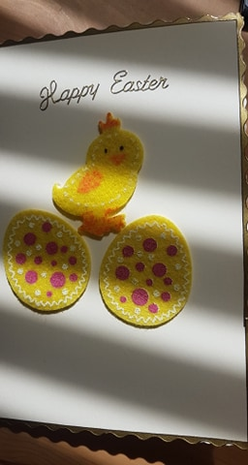
As I said, many people appreciate the ministry and support they receive from the church. Here is one of those message of thank you from them.
“Thank you for your help and guidance through these hard times, and those who have helped us with our shopping. I made this card and would have made more but was confined to our Flat. May we all have a blessed and happy Easter time. I am happy as the little chicken is.
From Beryl
Thank you so much to all our volunteers who deliver the groceries, who provide practical help and support to our neighbours, who help at Foodbank, who deliver the pastoral letters and the children’s craft packs.

Foodbank
Malcolm, who has been helping at Foodbank has written
The response from the ‘good folk of ABINGTON’ was tremendous. A steady stream of donations being brought to our house, and more have come this week. Today, through Donald’s involvement with the Rotary Club, we have received a wonderful donation of food from Waitrose which has helped us enormously in boosting our stocks which were becoming very low. Whilst this pandemic is very worrying for a lot of people, it is also bringing out the best in everyone. If you know or become aware of anyone or a family who are in very difficult circumstances, please let us know and we can get an emergency food parcel out to them.
You can contact Malcolm at malc.ward49@gmail.com. Thank you Malcolm and Jill and all those who support Foodbank. We also continue to pray for St. Alban’s Church and Revd. Judy, the vicar and our assistant Rular Dean.

Online Umbrella Church
There was the first Online Umbrella Church for children with a story and craft session through Facebook live. Thank you so much Alison, Amy and Cathy for that. If you would like to know more about it or the children’s craft packs that the Church is providing, please contact Alison at alison.canfield@sky.com.

The Eucharist for the frontline workers and Spiritual Communion
On Sunday 17th May, we are planning to celebrate the Eucharist and Spiritual Communion which will be dedicated to our key workers and health professionals and all those who lost their lives during this pandemic. I am working on the details to make this possible technically and liturgically and you will receive more information later. The service will include some modern interpretation of Spiritual Communion. Spiritual Communion has been practiced in Christian history when some Christian people found themselves isolated from the sacramental life of the Church for all sorts of reasons, and particularly in times of plague, famine and warfare. Spiritual Communion has been a way of uniting themselves with Jesus and entering into communion with him even though they are not able to receive the sacrament itself. It is still practiced particularly to those who cannot physically take the communion for whatever reasons.
You may want to get some bread and wine (or even grape juice?) ready for this service. It is just an option and not a must, so please don’t worry if you cannot. It is to help you to take part in the service more interactive way.

Prayer Exercise
Liz Kelly provided us another fun prayer exercise. It is attached to this letter. Thank you Liz.

Holy Land Pilgrimage Reflections
Cathy has shared with us her reflections on the Pilgrimage to the Holy Land. It is attached to this letter. Thank you Cathy.

That is all from me for this week. Please do keep sending me anything you would like to share or any prayer requests or suggestion or feedback on our worship.

Thank you so much to all of you who have sent me those lovely messages of encouragement and appreciation, thank you notes, letters and cards. I am most grateful for all that good wishes and blessings from you. It is a great comfort and encouragement to me and my family. Let us continue to encourage each other, bless each other. Let us keep up the good work of God.

With love in Christ

Jun

