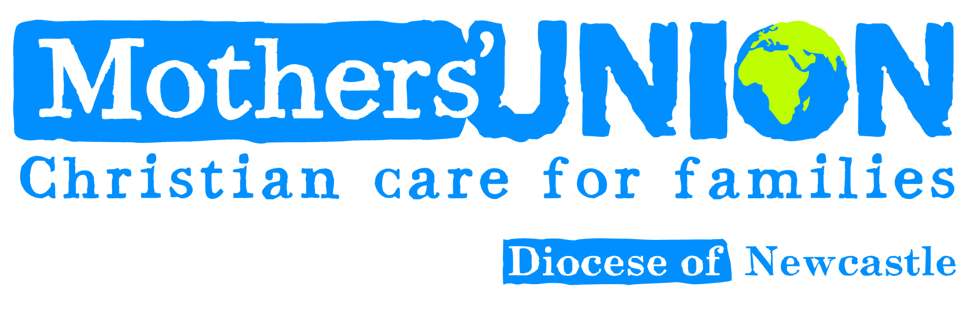

Diocesan Council Meeting & Annual General Meeting
to be held on Zoom on Friday 16th April 2021 at 10am
Please feel free to invite other members to attend

AGENDA
- President’s welcome.
- Opening worship led by our Chaplain, the Rev’d Dr Sarah Moon

Annual General Meeting
- The Annual General Meeting scheduled for 3rd April 2020 did not take place, owing to COVID, but all papers were distributed, and have already been discussed in October 2020
- Annual report 2020 (attached).
- Financial Report 2020 (summary and accounts attached)

Diocesan Council Meeting
- Apologies.
- Welcome to Members attending Council for the first time.
- Minutes of the last meeting held on 9th October 2020 (attached)
- Matters Arising.
- President’s remarks
- Safeguarding (report attached) Sheila Walker
- Unit Reports (attached)
a) Finance & Central Services Julian Brown
b) Marketing & Communications Barbara Packer
e) Action & Outreach Linda Benneworth
f) Faith & Policy Jackie Moore
g) Diocesan Members Edna Maddison
8. News from the Deaneries (attached)
9. Any Other Business.

Following the formal meeting there will be a short presentation by Carol Butler, our Diocesan Safeguarding Advisor

Midday Prayers, led by Sheila Walker, followed by the Grace

Please read and have available the Agenda and attached reports, which will not be read out at the meeting; but any questions will be answered. Please ensure that others attending Council by phone or Zoom also receive the papers.
All members are welcome to join us. The Zoom link and telephone numbers for Council are to be found in the email, which may be forwarded to members.

Elections

All elected Mothers’ Union officers serve for a period of three years, renewable just once. We are approaching the start of the election process for officers who will begin their work in January 2022. Many of our Trustees must step down, having completed six years in their current post. This makes way for new people with fresh ideas, but with the same enthusiasm for Mothers’ Union. Do consider this prayerfully. I have found these words to be true:

‘God doesn’t call the equipped
He equips those he calls’

God will lead us and equip us to do his work through Mothers’ Union.

The following is a list of the Trustee roles which will need to be filled, with a note of whether the current officer is eligible for re-election, or not:

Diocesan President *
Vice-President for Lindisfarne Archdeaconry *
Vice-President for Northumberland Archdeaconry *
Action & Outreach Co-ordinator *
Marketing and Communications Co-ordinator *
Faith & Policy Co-ordinator

* means that the current officer is not eligible for re-election in the same post

In addition, there will be elections for all Deanery Leaders, which will take place later in the year within the Deaneries.

Calendar
April
16th Diocesan Council 10a.m. – noon
30th Copy date for Summer Journal
May
15th Diocesan Eucharist by Zoom 11a.m.
31st – June 1st Diocesan Retreat, leaders Jennie & Malcolm Jones
June
11th Trustees meet by Zoom 11a.m.
July
1st A&O and F&P meeting by Zoom 10a.m. – 12 noon
10th Diocesan Festival
September
17th Trustees meet 10a.m.
25th Annual Gathering accessible to all by Zoom
October
23rd Diocesan Members Meeting 10a.m for 10.30a.m at Church House

